Lab 8:

Task 1:

Solution:

void setup() {

// put your setup code here, to run once:

pinMode(11,OUTPUT);

pinMode(13,OUTPUT);

pinMode(2,INPUT);

attachInterrupt(digitalPinToInterrupt(2),routine,CHANGE);

}

void loop() {

// put your main code here, to run repeatedly:

digitalWrite(11,HIGH);

delay(1000);

digitalWrite(11,LOW);

delay(1000);

}

void routine()

{

digitalWrite(13,HIGH);

}

Output:

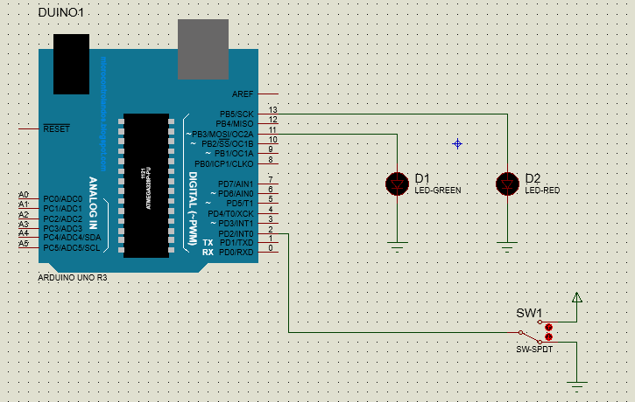

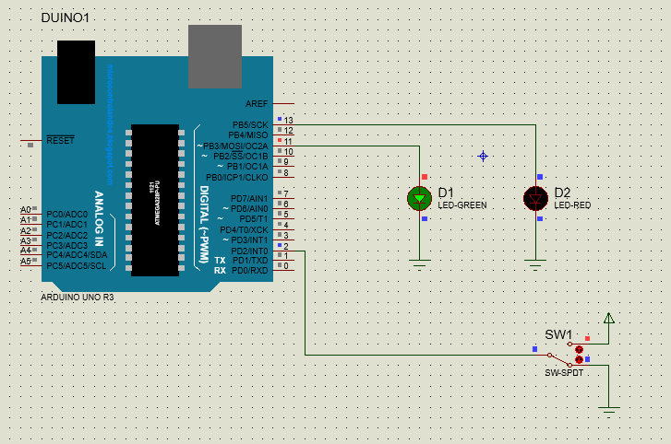

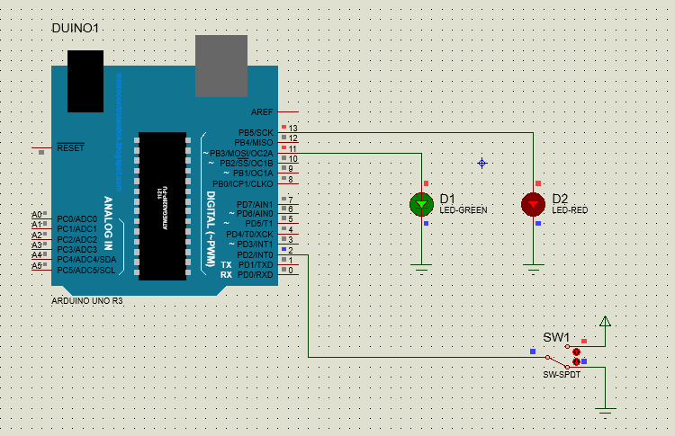

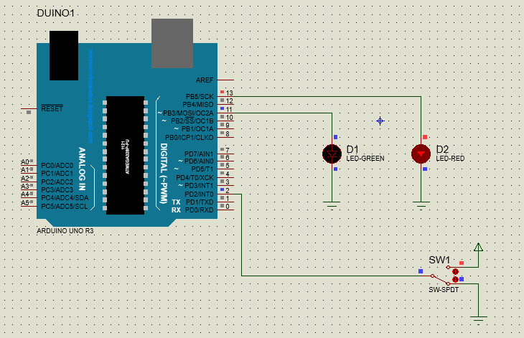

Task 2:

Solution:

#include <LiquidCrystal.h>

#include <TimerOne.h>

int led = 2; // led connect to pin 2 of arduino

int led_i = 3; // led_i connect to pin 3 of arduino

int x =0;

LiquidCrystal lcd(12, 11, 10, 9, 8, 7); // arduino pins for lcd connections

void setup() {

pinMode(led,OUTPUT);

pinMode(led_i,OUTPUT);

pinMode(4,INPUT);

lcd.begin(16,2);

Timer1.initialize(4000000); /// 4 sec timer

Timer1.attachInterrupt(interrupt);

}

void interrupt()

{

lcd.setCursor(0, 0);

lcd.print("Timer1 interrupt"); // ISR

if (x==LOW)

{ digitalWrite(3,HIGH);

x = HIGH;

}

else

{digitalWrite(3,LOW);

x =LOW;

}

}

void loop() {

delay(500);

lcd.clear();

digitalWrite(2 ,HIGH);

delay(1000);

digitalWrite(2,LOW);

delay(1000);

}

Output:

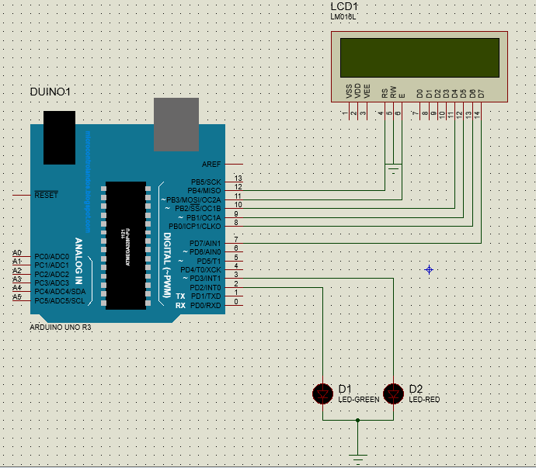

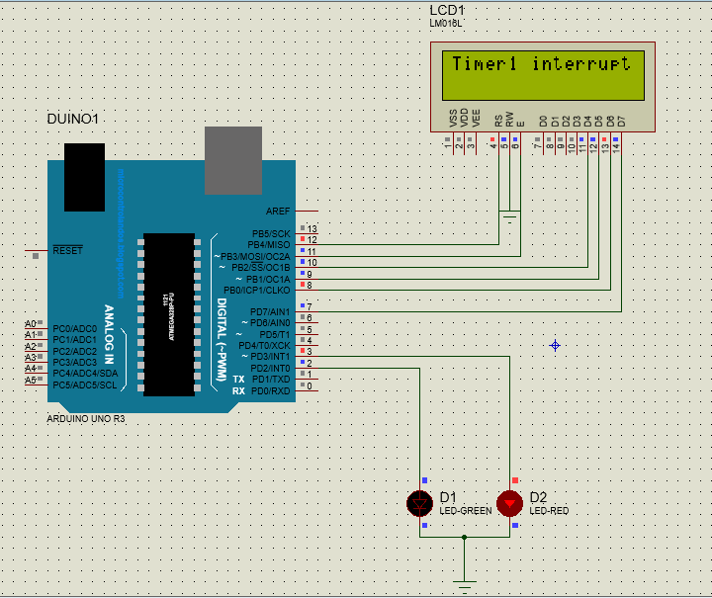

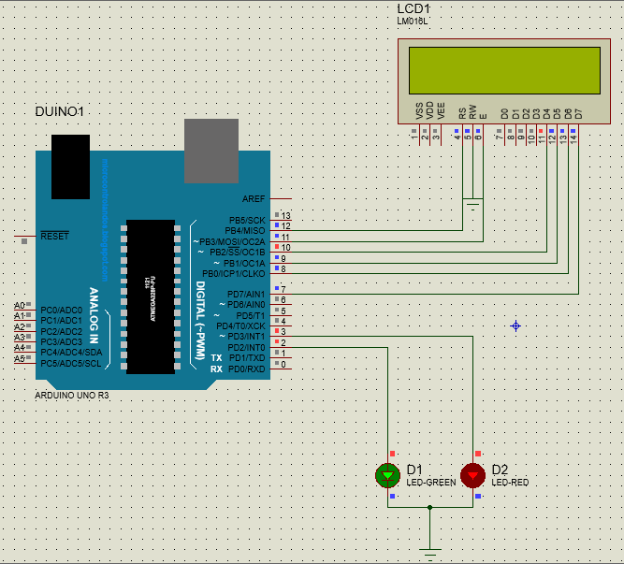

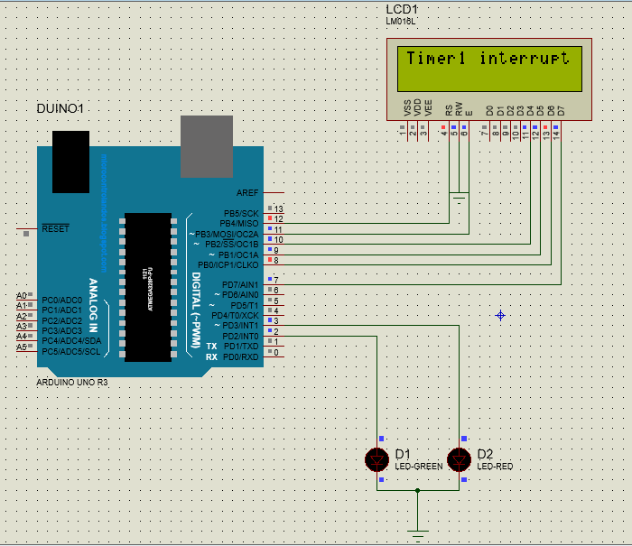

Task 3:

Solution:

int i=0;

int x=0;

void setup() {

// put your setup code here, to run once:

pinMode(11,OUTPUT);

pinMode(13,OUTPUT);

pinMode(2,INPUT);

attachInterrupt(digitalPinToInterrupt(2),routine,CHANGE);

}

void loop() {

// put your main code here, to run repeatedly:

digitalWrite(11,HIGH);

delay(1000);

digitalWrite(11,LOW);

delay(1000);

}

void routine()

{

x= ~i;

i=x;

digitalWrite(13,i);

}

Output:

